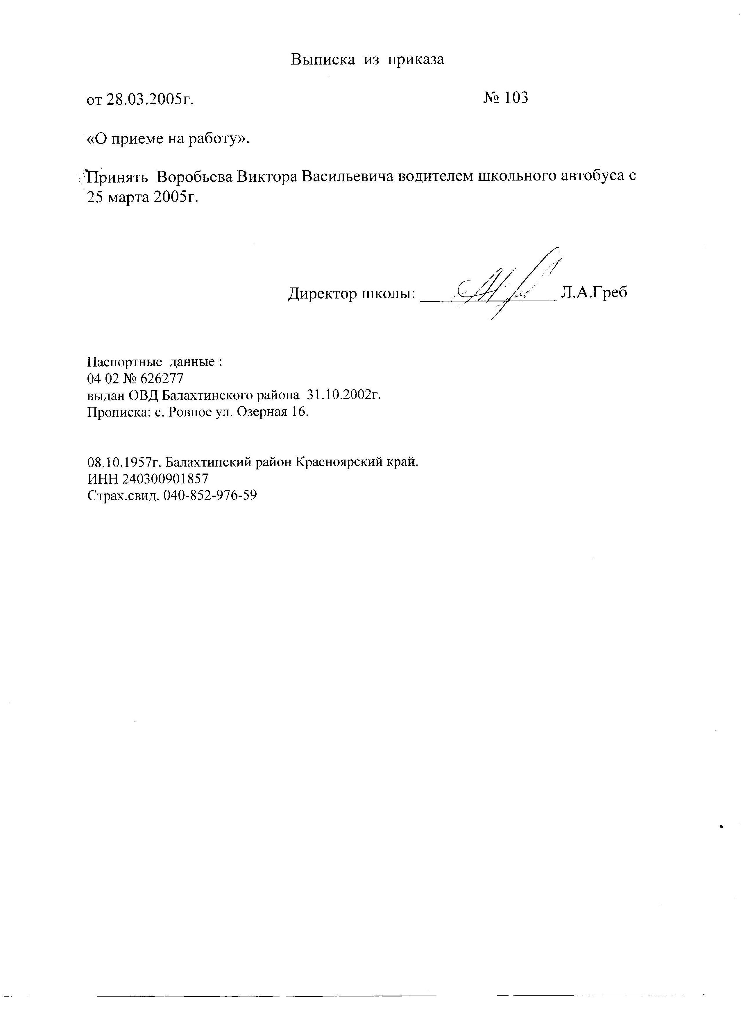

|  |  |
| --- | --- |
| C:\Users\школа\Pictures\img030.jpg | C:\Users\школа\Pictures\img030.jpg |

